19 CSE 102 – Computer Programming

LAB 2 - PART 2 - OPERATORS AND DECISION MAKING

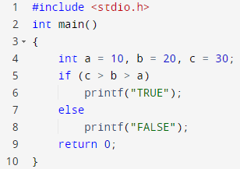

Output: Compilation Error

Explanation: In c programming we cant use c>b>a at once . It should be combined with some operator like &&.

1. Find the output of the following program and explain the reason leading to the output

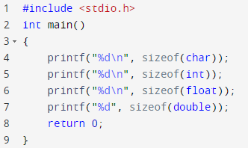

Output: 1

4

4

8

Explanation: The code returned the size or memory of the various data types.

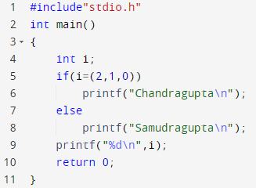

Output: Samudragupta

Explanation: The code assigned i value as 0 as 0 is being lastly assigned to i and in Boolean 0 means false so the else part runs so we got the output as ‘Samudragupta’.

4. Find the output of the following program and explain the reason leading to the output

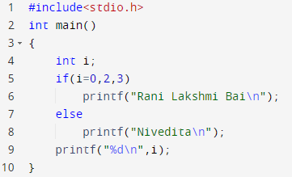

Output: Nivedita

0

Explanation: In the code we can see 0 is assigned to variable i so it is false and the else block runs.

1. Find the output of the following program and explain the reason leading to the output

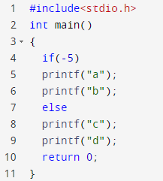

Output: Compilation error

Explanation: The if condition is satisfied but there are two blocks without curly braces which creates else statement to get an error as it is not linked with any if statement.

Find the output of the following program and explain the reason leading to the output

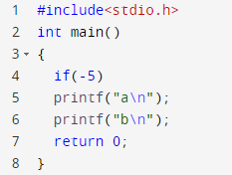

Output: a

b

Explanation: The condition for i is -5 which is not equal to zero so that means that is not false so it is true and the if block runs and the newline comment separately prints out b in separate line.

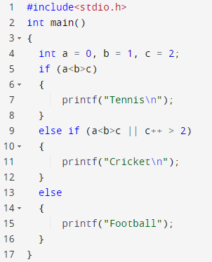

Output: Compilation error

Explanation: In c programming we can’t operate 3 comparisons conditions at once.

8. Find the output of the following program and explain the reason leading to the output

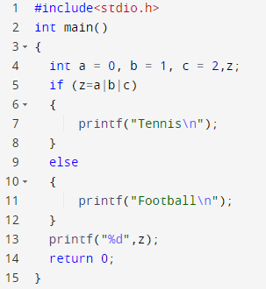

Output: Tennis

3

Explanation: The a|b|c bitwise or operator assigned 3 value in z because of which it if condition run.

9. Find the output of the following program and explain the reason leading to the output

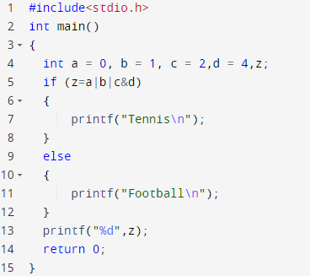

Output: Tennis

1

Explanation: The bitwise operator gives much preference to & bitwise operator than or. So the c&d operation gets run first.

10. Find the output of the following program and explain the reason leading to the output

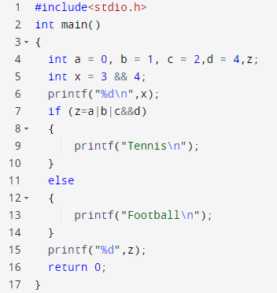

Output: 1

Tennis

1

Explanation: && will perform lofical operation which returns true and && operation will go on first in the if condition.

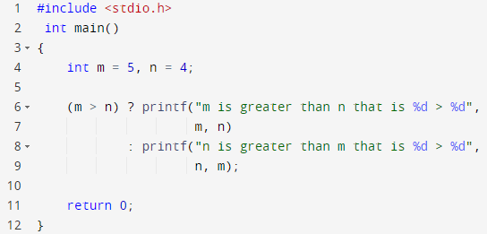

Output: m is greater than n that is 5 > 4

Explanation: Ternary operator. It will check the condition if it is true then it will run 1st condition if false it runs 2nd condition.

12. Find the output of the following program and explain the reason leading to the output

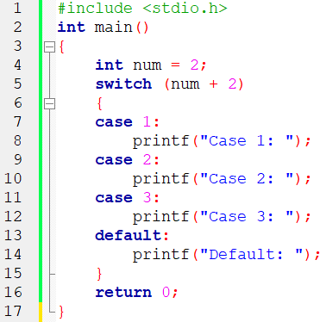

Output: Default:

Explanation: num+2 =4 and switch will check for case and print.

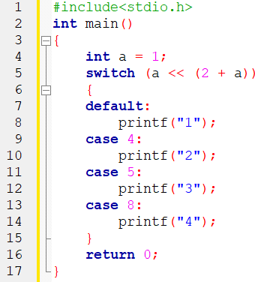

Output: 4

Explanation: The left assignment works with it <<.

14. Find the output of the following program and explain the reason leading to the output

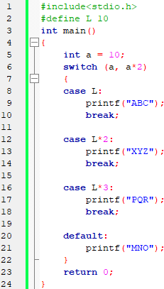

Output: XYZ

Explanation: The switch case checks and gets a\*2 so it prints XYZ.

15. Find the output of the following program and explain the reason leading to the output

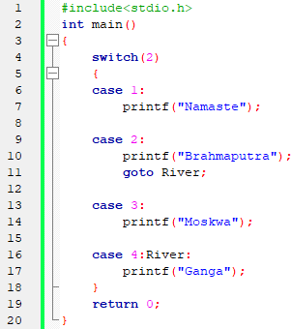

Output: BrahmaputraGanga

Explanation: The goto statement forwards it to case 4.

16. Find the output of the following program and explain the reason leading to the output

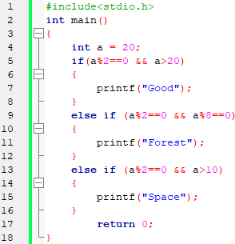

Output: Space

Explanation: It checks for all the conditions and runs the right one.